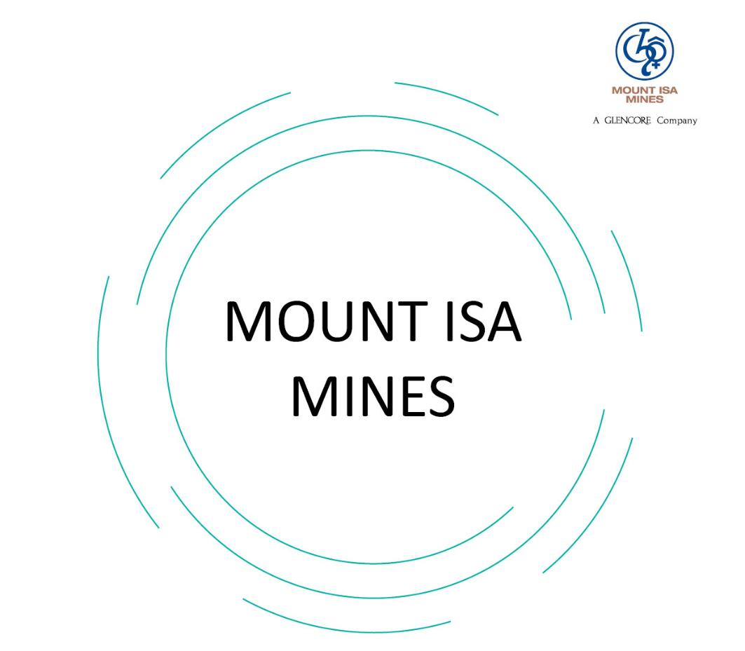

G-MIM-HSEC-GDL-Mount Isa Mines Visitor Handbook (120001)

Table of Contents
1. Visitor Checklist 3
2. Welcome 4
2.1. Copper Operations 4
2.2. Zinc Lead Operations 4
3. Important Requirements Before You Visit 5
4. Travel to Mount Isa 5
5. Policies and Procedures 5
5.1. Environment 5
5.2. Community 6
6. Your Safety 6
6.1. Visitor Access Conditions 6
6.2. Health and Hygiene 7
6.3. Lead and Other Contaminates 7
6.4. Personal Protective Equipment 7
7. Emergencies 7
7.1. Reporting Emergencies 8
7.2. Emergency Equipment 8
8. Leaving Site 8
9. Visitor Information and Induction Assessments 9
10. Definitions 10
11. Roles and responsibilities 10
12. References 10
12.1. Related Documents 10
12.2. Reference Information 10
13. Control and Revision History 11

Visitor Checklist
You must complete the following before gaining access to Mount Isa Mines:
- Complete our site Visitor Induction before you visit. This can be undertaken upon your arrival in Mount Isa at our Site Security Office, or alternately is available online at www.mountisamines.com.au. If you will be travelling underground during your visit you will need to complete both the Surface and Underground Inductions and associated paperwork.
- Complete the following forms located at the back of this booklet:
- G-MIM-HSEC-ASS-Mount Isa Mines Site Visitor Induction Assessment - Surface (120201)
- G-MIM-HSEC-ASS-Mount Isa Mines Site Visitor Induction Assessment - Surface and Underground (120202)
(if applicable)

- Send your completed form/s to your host who will lodge the paperwork with the Site Security Office

- Confirm your travel arrangements with your host well in advance of your visit

- Read this handbook and familiarise yourself with its contents

- On arrival in Mount Isa, visit the Site Security Office located at St Joseph’s Training Centre to finalise your site access. The Training Centre is located on the corner of Church Street and Railway Avenue.

If for some reason you are unable to print and complete the above forms prior to arriving for your visit, copies are available at our Site Security office which can be completed on your arrival.

Welcome
Welcome to Mount Isa Mines.
Located in mineral rich north-west Queensland, Mount Isa Mines operates two mining and processing streams, copper and zinc-lead, to deliver natural resources that have enduring roles in society. With one of the largest zinc resource base and the biggest underground network of mines in the world, we provide work for more than 3,700 employees and contractors.
Mount Isa Mines has a long and proud history, and recently celebrated 92 years of continuous operation. One of Australia’s largest and most complex mining and processing operations, the Mount Isa Mines site operates three underground mines, two concentrators, two smelters, and a zinc filtration plant.
Mount Isa Mines is a Glencore company, one of the world’s largest global diversified natural resource companies. The Mount Isa Mines operations are part of Glencore’s other operating assets within North Queensland – Lady Loretta Mine located 140 kilometres north west of Mount Isa, Ernest Henry Mine near Cloncurry, and the Townsville Copper Refinery and Port Operations. Together this group of assets are collectively known as Queensland Metals.
As well as the Australian market, our products are exported to 16 countries across Asia, Europe and the United Kingdom, contributing billions of dollars to the Australian economy every year.

Copper Operations
The Mount Isa Mines copper stream processes ore from the Enterprise and X41 underground copper mines and concentrate from the Ernest Henry Mine situated north of Cloncurry.
Ore is mined using traditional sub-level open stoping methods. Once the ore is loosened by drilling and blasting, it is mucked, crushed and hauled to the surface where it is put through the concentrating process.
During the concentrating process, waste is removed from the ore and a wet concentrate containing copper, iron and sulphur is produced. From the concentrator it is pumped to thickeners where the concentrate is allowed to settle to slurry. The slurry is then sent to hyperbaric filters for drying. The filtered and dried product is conveyed to the Stacker Reclaimer Storage Facility (or ‘The Dome’) to be blended with fluxes and Ernest Henry Mine concentrate.
During the next phase, smelting, impurities such as sulphur and iron are removed from the copper concentrate to form anode copper. Off -gases produced during this process are captured and treated at the adjacent acid plant, rather than being released into the atmosphere.
Smelting occurs at approximately 1200 degrees Celsius at the Copper Isasmelt Furnace. During smelting the molten material is separated into matte and slag.
The slag is reprocessed, but matte is transferred to the converters, where blister copper is produced. This blister copper is transferred to the Anode Furnace for refining into 99.7% pure Anode Copper. The molten copper is cast into moulds to produce Copper Anodes. The copper anodes, which weigh approximately 350 kilograms each, are transported to the Glencore’s copper refinery in Townsville for refining to 99.9% pure premium cathode copper. The Copper Cathode is then exported overseas via Glencore’s Townsville Port Facility.

Zinc Lead Operations
The Mount Isa Mines Zinc Lead Stream sources ore from the George Fisher and Lady Loretta Underground Mines.
Drilling and blasting practices are conducted to fragment the rock surrounding the ore. The ore is then mucked, crushed and either hoisted or hauled to the surface. Ore is transported from George Fisher Mine to the zinc lead concentrator by road trains via an off highway haulage road.
At the concentrator, the ore is ground in a series of mills and put through the flotation process to produce lead and zinc concentrate. The concentrate is then sent to thickeners where it is allowed to settle. Zinc concentrate is pumped to the Zinc Filter Plant where it is filtered and dried, then transported by covered rail wagons to Townsville where it is further refined and exported to overseas markets. The lead concentrate is pumped to the Lead Smelter for further processing
During the next phase, smelting, impurities are removed from the lead concentrate to form lead bullion.
For this to occur, the lead concentrate is dried to a clay-like consistency and mixed with raw materials, such as limestone and silica. It is then baked at 650 degrees Celsius to produce sinter.
The sinter is then blended with coke and fed into the Blast Furnace. Here, crude lead and slag containing impurities are separated through a thermal reduction process. Further impurities are removed via drossing, and the molten crude lead is then forwarded to the casting floor to be cast into four tonne blocks.
Throughout the lead production process, dust is captured and reintroduced with the lead concentrate as a wet paste. In this way it is recycled rather than being released into the atmosphere.
Approximately 10 kilograms of silver is contained in each lead block. These blocks, called Lead bullion, are transported to Townsville then shipped to Brittania Refined Metals in England for refining and sale on the London Metal Exchange.

Important Requirements Before You Visit
Before you can visit Mount Isa Mines, you need to undergo an induction so that you understand our safety rules and procedures as well as other important aspects of our operations. Our induction program includes three parts:
- View our Visitor Induction Videos on our website at www.mountisamines.com.au. If you are travelling underground during your visit you must complete both the Surface and Underground Visitor Inductions.
- Complete the forms included at the back of this handbook
- Send your completed forms to your host so that site access can be arranged.
This handbook provides you with general information about our site. Depending on what areas you will be visiting on site, you may need to undergo further area specific inductions which will be coordinated by your host.
Every visit to Mount Isa Mines requires the approval of a Mount Isa Mines representative who will take responsibility for your safety and visit and who will be your host while on site. Please ensure you know the name of your host and confirm necessary visit arrangements with them.

Travel to Mount Isa
Mount Isa is well serviced by commercial air operators with several flights per day to and from Brisbane and Townsville. For further information and or details of available flights, we recommend you check online.
Car hire is available from the Mount Isa Airport, with several of the major car hire retailers operating here. 4WD hire is also available.
Mount Isa has a multitude of accommodation options. We recommend you book any required accommodation early as these can fill up well in advance during busy periods.
For further information visit the Mount Isa City Council website https://mountisa.qld.gov.au

Policies and Procedures
As a visitor, you must follow site rules and procedures which govern environmental protection, cultural heritage management, health and safety. You may also be seen as a representative of our site if you are in contact with our local community.
The rules governing the conduct of everyone on site are based on the Queensland Mining and Quarrying Safety and Health legislation, one of many legislative or regulatory requirements that apply to our mining operation, as well as company policies and procedures. Copies of these materials are available on request. The key things you need to know are summarised in this handbook as well as the online Visitor Induction videos.
At Mount Isa Mines, we are committed to the highest standards of health and safety, environmental performance and community cooperation. We balance social, environmental and economic considerations in how we manage our business.

Environment
Mount Isa Mines strives for industry leadership in environmental performance and operates under environmental regulations set by the Queensland Government.
These define the contemporary standards we are required to comply with and include systematic and transparent reporting frameworks.
Over our long history we have achieved significant and consistent improvements in our performance in the areas of air and water quality, noise and vibration, land rehabilitation and waste management.
This includes operating one of the most intensive air quality monitoring systems of any city in the world.
Off-site, we take a variety of actions to measure and manage the potential impacts of our operations on our community.

Cultural Heritage Management
The Mount Isa Mines lease is located on the Traditional Lands of the Kalkadoon People. Several sites of cultural significance are located on the lease that are important to the history and culture of the Kalkadoon. We respect the Kalkadoon local customs and values and require all visitors to do the same.

Community
Mount Isa Mines is proud of its reputation for social responsibility. Our community relations practices are characterised by open and honest engagement with all our stakeholders through effective and transparent communication.
We support the sustainability of local communities by developing partnerships, generating employment opportunities, supporting local businesses, funding community projects and contributing to government royalties, taxes and charges.
Mount Isa Mines employees are given the opportunity to realise their full potential through training and personal development. We operate under the Glencore Code of Conduct and encourage our employees to be ambassadors for our core values. We do not tolerate any form of harassment, bullying, discrimination or physical assault on site.

Your Safety
Mount Isa Mines’ first priority in the workplace is to protect the health and well-being of all our workers. We take a proactive approach to health and safety; our goal is continuous improvement in preventing occupational diseases and injuries. Our SafeWork initiative ensures that all employees, contractors and visitors to site are aware of the Life Saving Behaviours and Fatal Hazard Protocols developed as part of SafeWork, and follow these as appropriate within the working environment.
Remember, for your safety it’s important you fully understand and comply with the conditions of access to the Mount Isa Mines lease.

Visitor Access Conditions
All visitors to Mount Isa Mines are required to report to the Site Security Office upon arrival to sign the visitors register and be provided with a Visitors Tag. You must wear the tag in plain view at all times. Accompanied Workers are also required to sign the visitors register and will be provided with an Accompanied Workers Tag that includes a photo. These tags authorise your entry to the site under the direct supervision of your host.
Your host will be a Mount Isa Mines site representative who will have the necessary authority to escort visitors on the Mount Isa Mines Lease. You are required to remain with your host at all times and follow any directions given by them. When walking on site, please ensure you walk along designated walkways and make sure you are clearly visible to equipment and machinery operators. You must maintain your awareness of and give way to all mobile equipment.
Visitors are not permitted to work while on site. Should you be required to perform work you may be considered an accompanied worker, please discuss this with your host.
Accompanied workers are permitted to perform limited work on site and are not permitted to perform manual labour, or operate vehicles, mobile equipment or plant.
Seat belts are to be worn at all times while travelling in a vehicle on site.
Barricades are erected for restricting access to hazardous or potentially hazardous areas. As a site visitor you should never enter a barricaded area. If unsure, ask your host.
Please refrain from taking photographs and video images unless you have prior approval from the Department Manager or authorised persons.
All employees, contractors and visitors on site have a legal obligation called ‘duty of care’ not to expose themselves or others to unnecessary health or safety risks.

Health and Hygiene
You have an obligation to notify your host of any medical conditions that may impact on your safety and the safety of others.
Mount Isa Mines has a well-established alcohol and drug testing and management process. This includes zero alcohol tolerance. You are not permitted to bring drugs or alcohol onto the lease. Please be aware you may be required to undergo a random drug and alcohol test while visiting our site. If you refuse to participate your access will be withdrawn.
If you are using prescription drugs, you must inform your host of the details of the medication and any possible side-effects or limitations caused by the medication. Smoking is restricted to designated areas only.
All persons accessing the Mount Isa Mines lease require various degrees of health assessment (including documentation and records) dependant on the role being performed while on site. This is included in site access administration prior to site entry.

Lead and Other Contaminates
Mount Isa Mines has comprehensive measures in place to manage worker health and minimise occupational exposure to lead and other contaminates.
Lead and other contaminants can enter the body through inhalation, ingestion or occasionally skin contact. Protocols to reduce risk of exposures can include respiratory protection, mandatory washing before meal breaks, eating only in designated areas, drinking only from designated water coolers, and refraining from biting your fingernails. We also enforce a mandatory Clean-In Clean-Out Policy in lead-risk areas which involves showering on completion of each shift, on-site laundering of work clothes and on-site vehicle refuelling and wash down bays.
All vehicles and equipment exiting the lease must exit the lease via the wheel wash to minimise the risk of contaminants being taken into the community.
A community awareness program informing families on how to live safely in an area where lead is present from natural and industrial sources is also supported in Mount Isa through our involvement in the Lead Alliance. Mount Isa Mines offers free blood lead testing to all local residents.

Personal Protective Equipment
Fully enclosed footwear is a requirement in all areas of the site, with steel capped safety boots, hard hat, long sleeved shirt, long pants and safety glasses required when entering the operational areas. Additional personal protective equipment (PPE) may be required in designated areas, such as respirators, hearing protection or high-visibility clothing. . Your Personal Protective Equipment must be worn correctly at all times whilst on site.
Temperatures in Mount Isa can climb well above 40 degrees, so please drink water regularly from potable water sources, and wear sunscreen and sun protection when outdoors.

Emergencies
We have an emergency management system in place which includes onsite emergency response from the Queensland Ambulance Service, Queensland Fire and Emergency Services and fully trained Mine Recue personnel.
Should an emergency evacuation occur during your visit, a loud emergency alarm will sound, or announcements will be made via radio or clear calls dependant on your location. Your host will advise you of your nearest emergency assembly point. Stay with your host at all times and follow their instructions as they guide you to one of these locations.

Reporting Emergencies
If you require emergency assistance and your host is unable to assist, you must report the emergency immediately in one of the following ways:
- Call 2222 from any site telephone
- Call 4744 2222 from any other phone, including mobiles.
- Start your call by saying ‘This is an emergency’.
- Most importantly, do not hang up until you have been told to do so.
Should you or your host be unable to reach or use a telephone, you should look for a radio or clear call to announce your emergency.
When using a hand held or vehicle radio, announce your call with ‘emergency, emergency, emergency’. If there is no response, try again.

Emergency Equipment
Emergency equipment and facilities are located around the site and are easily identified by signage or lighting. Fire extinguishers are also located in company vehicles. You should familiarise yourself with the locations of emergency equipment when travelling through the operating plant and buildings. Remember, in the event of an emergency follow your host’s directions.

Leaving Site
When leaving Mount Isa Mines, please ensure you return your site access card, together with any Personal Protective Equipment provided for the visit to your host.

Important Contact Numbers
Emergency | 4744 2222
Site Security Office | 4744 3343
Site Medical Centre | 4744 2242
Main Reception | 4744 2011 (24 hrs)

My host
Name
Phone

Visitor Information and Induction Assessments
The following forms must be completed and given to your host before or on arrival at Mount Isa Mines. Failure to complete the appropriate form/s will result in access to site being denied.
Please ensure you complete all sections of the attached G-MIM-HSEC-ASS-Mount Isa Mines Site Visitor Induction Assessment - Surface (120201), including:
- Assessment detail and trainee sign off (including emergency contact information)
- Medical details
- Surface written assessment
If you are required to travel underground during your visit, please ensure you also complete the attached G-MIM-HSEC-ASS-Mount Isa Mines Site Visitor Induction Assessment - Surface and Underground (120202), including
- Assessment detail and trainee sign off
- Medical details
- Underground written assessment
If you are unable to print and complete these forms prior to arriving for your visit, copies are available at our Site Security office which can be completed on your arrival.

Definitions
Acronyms and key terms used within this Guideline are defined in Table 10-1.
Table 10-1 – Definitions of acronyms and key terms
Definitions
N/A

Roles and responsibilities
Roles and responsibilities required for the implementation of this Guideline are outlined in Table 11-1.
Table 11-1 – Roles and responsibilities
Role | Responsibilities
N/A

References
Relevant reference information such as legislation and standards should be included in the site management system and must be regularly reviewed for updates. Reference material cited in this section provides source information for developing and maintaining site compliance.

Related Documents
Internal documents, as listed in Table 12-1, are directly related to or specifically referenced in this Guideline.
Table 12-1 – Related documents
Title
G-MIM-HSEC-ASS-Mount Isa Mines Site Visitor Induction Assessment - Surface (120201)
G-MIM-HSEC-ASS-Mount Isa Mines Site Visitor Induction Assessment - Surface and Underground (120202)

Reference Information
External reference information, as listed in Table 12-2 is directly related to the development of this Guideline or referenced from within this document.
Table 12-2 - Reference Information
Title
N/A

Control and Revision History
Table 13-1 – Control and Revision History
Version | Date | Reviewers | Change Summary
2.0 | 28/06/2021 | B Bravos, G Palm | Document updated – to align form to changes in G-MIM-HSEC-PRO-Site Access and Security – Workers and Visitors (120000)

